273/1
GEOGRAPHY
Paper 1
AUGUST, 2022
2hours 30 minutes

JINJA JOINT EXAMINATIONS BOARD

Uganda Certificate of Education

MOCK EXAMINATIONS – AUGUST, 2022

GEOGRAPHY

Paper 1

2 hours 30minutes

INSTRUCTIONS TO CANDIDATES:
This paper consists of parts I and II.
Part I and Section A of part II are compulsory.
Answer only one question from section B of part II.
Answers to all questions must be written in the answer booklets provided

PART I
OBJECTIVE-TYPE QUESTIONS (30 MARKS)
These are 30 compulsory questions. Each question carries one mark.
Answers to this part must be written in the answer booklet provided.
- The main factor influencing the development of a soil catena in East Africa is
- Vegetation
- Relief
- Climate
- Drainage
- Lake Teleki in Kenya is an example of a
- Rift valley lake
- Glacial lake
- Crater lake
- Down warped lake
- The problem of traffic congestion in Kampala is mainly being solved by
- Increasing the number of traffic police
- Installing traffic lights
- Constructing flyovers
- Using public transport
- The major export from Uganda is
- Flowers
- Frozen fish
- Coffee
- Limestone
- The major problem facing the fishing industry in East Africa is
- Limited fish species
- Inadequate transport
- Limited capital
- Limited market
- The major tourist attraction in East Africa is mainly
- Lakes
- Wild life
- Historical sites
- Towns
- Which of the following towns developed mainly as a result of mining?
- Arusha
- Dares salam
- Kilembe
- Nairobi

- The most common type of fish caught on Lake Tanganyika is
- Nile perch
- Tilapia
- Cod
- Dagaa
- Which of the following is the most widespread agent of soil erosion in East Africa?
- Wave action
- Running water
- Wind action
- Glaciation
- The instrument used to measure the speed of wind at a weather station is
- Wind vane
- Barometer
- Anemometer
- Hydrometer
- The miombo woodlands are sparsely populated mainly because of
- Remoteness
- Tsetse flies
- Poor soils
- Thick vegetation
- Temperature inversion in East Africa is mainly experienced in
- Lake Victoria
- Busoga region
- Coastal regions
- Kigezi highlands
- After the failure of ground nuts, Kongwa scheme is now used for
- Cotton growing
- Wheat growing
- Ranching
- Rice growing
- Which of the following activities is mainly responsible for deforestation in East Africa?
- Agriculture
- Charcoal burning
- Bush burning
- Lumbering
- small scale industries should be encouraged in East Africa mainly because they;
- Are cheap to set up
- Require semi skilled labour
- Provide employment
- Provide foreign exchange

- Which of the following factors is the greatest problem facing the mining sector in East Africa?
- Frequent mining accidents
- Exhaustion of minerals
- Inadequate capital
- Limited transport
- The main reason for the development of road transport in Uganda is
- Supportive government policy
- Adequate capital
- Cheap labour
- Political stability
- The highland areas of East Africa are agriculturally productive mainly because of
- Fertile soils 3. Reliable rainfall
- Efficient transport 4. Abundant labour
- 1 and 2 C. 1 and 3
- 2 and 3 D. 3 and 4
- Stephen is a tourist facing east. What will his new direction be if he turns 270⁰ clockwise?
- North
- West
- South
- South East
- North – Eastern Uganda is sparsely populated mainly because of
- Infertile soils
- insecurity
- Un reliable rainfall
- Remoteness
- Material carried along by a glacier is called
- Silt
- Scree
- Moraine
- Alluvium
- The major factor for the development of fish farming in East Africa is to
- Earn income for farmers
- Reduce overfishing
- Increase food production
- Promote fish export
- The major factor affecting the distribution of vegetation in East Africa is
- Relief
- Bush burning
- Climate
- Drainage

24. The major problem limiting agricultural modernization in East Africa is
- Shortage of skilled labour
- Remoteness
- Shortage of capital
- Pests and diseases
- The most effective way of solving the problem of land shortage in urban areas is by;
- Upgrading slum areas
- Constructing sky scrapers
- Encouraging urban – rural migration
- Reclaiming wetlands
- Mt. Rwenzori is visited by tourists mainly because of;
- Gorillas
- Glacier
- Monkeys
- Baboons
- The major reason for carrying out population census in Uganda is
- To know the number of people in a country
- To plan for services
- To develop the areas
- To provide security
- A steep sided feature formed between two adjacent cirques is called
- A pyramidal peak
- Hanging valley
- An arête
- Glacial trough
- The major reason for planting exotic soft wood trees in Kenya is because.
- They provide firewood
- They are source of timber
- They mature faster
- They control soil erosion
- The major cause of desertification in Northern Kenya is
- Overgrazing
- Bush burning
- Deforestation
- Dry winds

PART II
MAPWORK, PHOTOGRAPH INTERPRETATION, FIELD WORK AND EAST AFRICA
Answer four questions from part II, including Questions 1,2 and 3 which are compulsory.

SECTION A

- COMPULSORY QUESTION: MAP WORK (20 MARKS)
Study the EAST AFRICA 1: 50,000 (UGANDA) PAKWACH Map extract part of Sheet 29/2, Series Y732, Edition2-U.S.D and answer the questions that follow:

(a) (i) Name the drainage feature found at grid reference 262711. (01 mark)
(ii) State the grid reference of the borehole north of Panyigoro. (01 mark)
(b) (i) Measure and state the distance in Kilometers covered by the loose surface road on the
map extract. (02 marks)
(ii) Calculate the area covered by Albert Nile on the map extract. (02 marks)
(c) Draw a cross section from grid reference 180680 and 250680 and on it mark and name:
(i) River Abongo
(ii) Scrub vegetation
(iii) Hill
(iv) Transport routes
(v) Settlement (06 marks)
(d) Giving evidence from the map extract identify the
(i) Types of settlement shown on the map. (02 marks)
(ii) Economic activities carried out in the area. (03 marks)
(iii) Problems facing the people living in the area. (03 marks)

- COMPULSORY PHOTOGRAPH INTERPRETATION (15 MARKS).
Answer all parts of this question
Study the photograph provided below and answers the questions that follow:
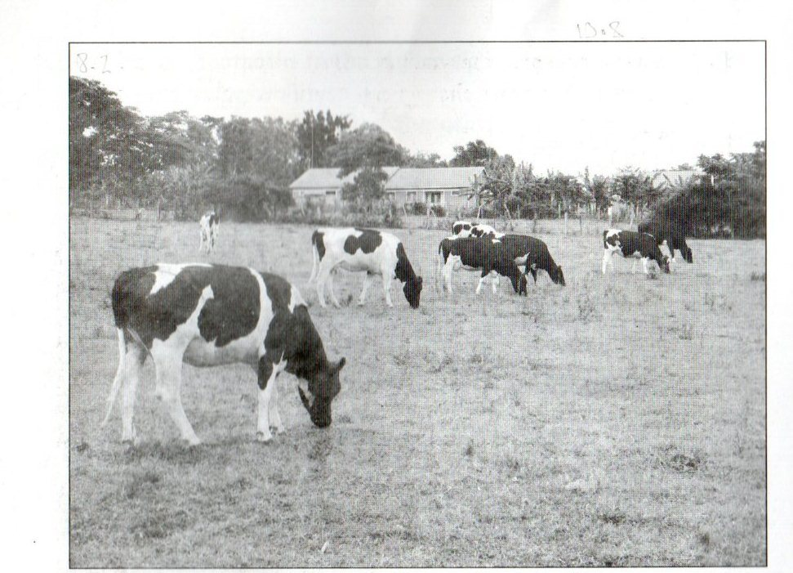

- Draw a landscape sketch of the photograph and on it mark and name:
- Vegetation types
- Relief feature
- Land use types (05 marks)
- Giving reasons for your answer identify:
- The type of photograph (01 mark)
- The economic activity taking place in the middle ground of the photograph.
(01 mark)
- Describe the conditions which have favoured the economic activity in (b) (ii) above.
(04marks)
- (i) Outline the environmental problems resulting from the activity in (b) (ii) above.
(03 marks)
(ii) Suggest one area in East Africa where this photograph could have been taken. (01 mark)

- COMPULSORY FIELD WORK QUESTION (15 MARKS)
For any one field work study you have conducted:
- State the:
- Topic, (02 marks)
(ii) Objectives of the field work study. (02 marks)
- Describe how you used any two of the following fieldwork methods to collect information
during the study.
- Observation
- Recording
- Measurement
- Interviewing. (04 marks)
(c) Explain the findings of the field work study. (03 marks)
(d) Outline the activities you did after the field work study. (04 marks)

SECTION B: EAST AFRICA (20MARKS)
Answer only one question from this section.
- (a) Draw a sketch map of East Africa and on it, mark and name:
- Lakes: Tanganyika and Victoria
- Arms of the rift valley
- Mountains: Elgon and Kenya. (07 marks)
(b) Describe the process responsible for the formation of any one mountain above. (05 marks)
(c) Explain the importance of volcanic mountains to the people of East Africa. (05 marks)
(d) Outline the problems faced by the people living in mountainous areas of East Africa.
(03 marks)
- (a) Study the climate statistics of station A in East Africa and answer the questions that follow:
STATION A: LATITUDE 1067 meters
MONTH | J | F | M | A | M | J | J | A | S | O | N | D
TEMP(C) | 23 | 23 | 22 | 22 | 20 | 20 | 19 | 19 | 22 | 24 | 23 | 24
R/FALL(MM) | 203 | 191 | 356 | 627 | 244 | 109 | 33 | 31 | 28 | 05 | 114 | 190
Adapted; Hickman, G (1995) lands and people of EAST AFRICA. P33
- Draw a suitable graph to show the climate of the station. (08 marks)
- Calculate the annual:
- Total rainfall
- Range of temperature for station A. (04 marks)
(b) Describe the characteristics of the climate experienced at station A. (04 marks)
(c) Giving reasons for your answer outline the economic activities that can be carried out around
station A. (02marks)
(d) Explain the problems likely to face the people living in the area around station A. (02marks)

6. (a) (i) Define the following terms:
- Marine fishing
-Fresh fishing. (02 marks)
(ii) Name one fish species caught in:
-Marine waters
- Fresh waters (02 marks)
(b) Describe the conditions which have encouraged fishing in any one country in East Africa.
(06marks)
(c) Explain the benefits of fishing industry to the people of East Africa. (06 marks)
(d) Outline the measures being taken to improve the fishing industry in any one country selected in East Africa in (b) above. (04 marks)

7. (a) Draw a sketch map of East Africa and on it, mark and name:
(i) Industrial towns: Nairobi, Jinja and Dares salam
(ii) Rivers; Tana, Rufigi and Nile. (07marks)
(b) Name any two types of industries found in any one industrial town marked in (a) (i) above.
(02 marks)
- Describe the factors that have led to the development of industries in East Africa. (06 marks)
- Outline the problems which have resulted from industrial development in East Africa.
(05 marks)

